

Department of Mechanical Engineering
One Page Abstract

Course name/  Course code | Mini Project / U23MEW602 |  |  | Year / Sem: III / VI
 |  |  |  | Batch: 2023 - 2027
Title | IoT BASED COAL MINE MONITORING AND SAFETY SYSTEM
Domain | IoT/Data analytics/Environmental Monitoring/Industrial Safety
SDG Supports | SDG – 3 | Good Health and Well-being.
 | SDG – 8 | Decent work and Economic.
 | SDG – 9 | Industry, Innovation, and Infrastructure.
Abstract | Coal mines are hazardous environments where workers are exposed to toxic gases, high temperatures, dust, and low oxygen levels. This project proposes an IoT-based coal monitoring and safety system to improve mine safety through real-time environmental monitoring. The system uses sensors to detect parameters such as methane gas, carbon monoxide, temperature, humidity, and dust concentration inside the mining area. These sensors are connected to a microcontroller, which collects and transmits data to a cloud platform using wireless communication.  If any parameter exceeds the safe limit, the system automatically sends alerts to workers and control rooms, helping prevent accidents and health risks. The system also stores data for analysis, helping authorities identify dangerous patterns and improve safety measures. This solution supports safer working conditions, reduces workplace accidents, and promotes sustainable mining operations. The proposed system is cost-effective, reliable, and suitable for real-time industrial safety applications.  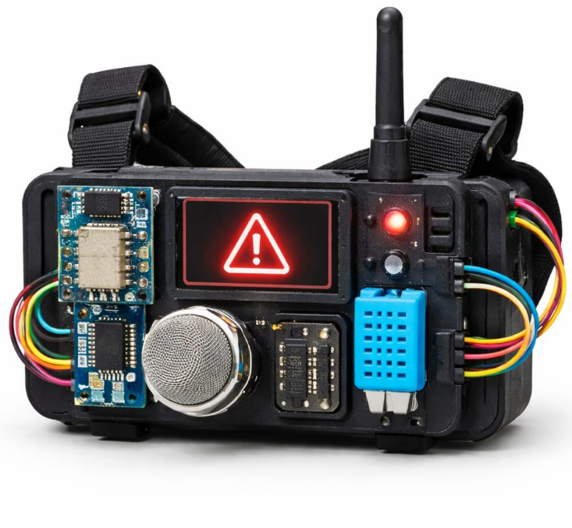
Team Members | Register No |  | Name |  | Name of Guide  Designation
 | 23UME023 |  | GOPU MS |  | Dr.K.HEMALATHA-  (HoD & Associate Professor)
 | 23UME032 |  | KISHORE M
 | 23UME039 |  | NARESH KUMAR C |  | Signature
 | 23UME052 |  | RUPAGANESH C

